Bed & Breakfast

Reservation

and

Accounting System

Software Development Plan

11 October 2015

Michael Straughan

Lead Software Engineer

CMIS 330 6381

Software Engineering Principles and Techniques

Ronald McFarland

**1. Introduction**

The software development plan is a document that contains all the information required to manage the development of the Bed and Breakfast Reservation and Accounting System. This document will lay out all the standards, tools, strategies and resposibilities for the development of the system to the defined specifications.

## **1.1 Purpose**

The purpose of this Software Design Document is to expand upon the Software Requirements Specification by defining an implementation of the "Bed and Breakfast Reservation & Accounting System". It should give all parties the necessary information of what is to be built and how it is expected to be built.

## **1.1 Project Summary**

**1.1.1 Purpose, Scope and Objectives**

The BBRAS will be used by management and customers in order to process reservations. The system will also store reservation data, customer data, account data to include credit card information. The system will also be utilized to provide reservation and financial data reports to be used by the management to evaluate the business operations.

The scope of this system is limited to the users and to its user functions. The system is to be designed as an enclosed, stand-alone system. The interactive elements are ones that meet the requirements outlined in the System Requirements Specification. Streamlining the functionality of this system will eliminate user frustration by eliminating the possibility of an over complicated and over burdened system.

The objective of the system is to simplify the reservation process on the user side and to provide financial reports for the management. The system goal is to encapsulate all the processes that are not entirely dependent on the user and hide them behind the scenes to create a semi-automated system.

Successful completion of the project will be considered as meeting all the project milestones and providing the management with a completed product by the delivery date set in the requirements.

## **1.1.2 Assumptions and Constraints**

An existing hardware platform for software deployment is assumed to be installed, in-place and ready to to use. This hardware system is not a part of the requirements as defined in the SRS. Assumptions of the management and users are also made. It is assumed that there is access to the system by both parties, whether it is in person or by proxy over the phone. Finally, it is assumed that there is an established connection to credit card verification sources, whether it is internet for telephony.

There are not very many assumptions made of the BBRAS software itself. It is not required or constrained that the system need to be mobile or stationary, nor is the use of proprietary or open source software defined. For the ease of use, a multi-platform, portable approach utilizing open source software will be taken in the creation of the BBRAS.

## **1.1.3 Project Deliverables**

The project deliverable will be as follows:

* Software Package
  + Calender Reservation UI
  + Guest Information UI
  + Reporting UI
  + Persistent Reservation Background Service, with connectivity to the databases and UI
* System Manual

The software deliverable will be a Java application in jar executable format that is compatible with Microsoft Windows and a configuration file for database connection to Microsoft Access, as defined in the Software Test Specification. The software will be available in digital download format and on a USB flash drive. The system manual will be in physical format, available for digital download, as well as included in digital format on the USB flash drive.

## **2. References**

References are made to the following documents:

* Software Requirements Specification
* Software Design Document
* Software Test Specification
* Software Development Plan

# **3. Definitions**

# **4. Project Organization**

This section will define how the project team will be organized for the development and maintenance of the BBRAS.

## **4.1 External Interfaces**

External interfaces are directly limited to the customer due to the small size of the project team and the limited functionality of the BBRAS.

## **4.2 Internal Interfaces**

The project team will consist of the following: 1 Java Developer, 1 UX Architect, 1 Project Manager, for a total of 3 members. This limited team will be able to fully meet all the requirements for all stages of the project. External communication with the management will be handled with the Project Manager during the development of the software requirements. During the design and subsequent evaluation of the UI, the Project Manager and UX Architect will coordinate with the management. The layer of overlap will emphasize transparency while still utilizing each members specialization during the project.

The project team is structured to compartmentalize each processes during the development phases of the BBRAS. The Java Developer will be isolated away from the management during development to ensure focus on portions of the system that the management will never need to touch. The Project Manager will be in direct communication with the management to ensure that the development from the Project team is meeting the requirements made by the management and to facilitate any changes in the requirements or system that might come up. The UX Architect, along with the Project Manager will work together with the management to ensure that the actual usable portion by the customers and management are what is expected and defined by the requirements.

All communication internally and externally is handled by the Project Manager. This member is the focal point for all work being done as per the requirements, any changes to those requirements, and that the deliverables meet the expectations of the management.

This team structure of isolation, overlap and responsibility should enable flexible development of the BBRAS.

Software version control for the BBRAS will use Git. To ensure quality control through the use of Git, the developers (which include the Java Developer and the UX Architect) will use the following guidelines:

* Commit to Source Repository every work day.
* Commit to Source only after sufficient Testing

Automated test suites will follow the requirements set inside the Software Test Specification. This will proceed commits to the source code repository. Committing to Git will have a hook to run automated tests after each commit. This will ensure that all new development will follow the SRS and be fully tested after a commit.

## **4.3 Roles and Responsibilities**

Each member of the Project Team is defined in the following roles and responsibilities:

**Java Developer**: Develop software with the latest version of Java. Must be competent in Java Language and Java APIs used to develop cross-platform applications. Must have knowledge of databases, data structures, data connectivity and data persistence. Required to test and validate the software and databases according to the requirements.

**UX Architect**: Create the design interfaces, focusing on end-user experience. Sketch mock-up GUI prototypes for review with the management. Coordinate with the Project Manager and management to provide a GUI that meets the requirements and functionality of the BBRAS. Develop pseudocode or prototype Java code for further refinement/refactoring by the Java Developer. Coordinate with the Java Developer in creation of the GUI portion of the software.

**Project Manager**: Manage the Project Team members. Oversee all aspects of the development of the BBRAS. Ensure project development tracks and will meet milestones, deadlines and project delivery date. Coordinate with the management on the development of the Software Requirement Specification and during all phases of the development of the BBRAS. Coordinates scheduling of resources between all aspects of the project.

# **5. Managerial Process Plans**

This section defines the work schedule and task structure required to meet the timeline as per the requirements.

## **5.1 Work Plan**

This section breaks down the tasks in the project schedule.

## **5.1.1 Work Activities**

The following table provides a full breakdown of the tasks included in ithe master work schedule of the BBRAS software development lifecycle.



**5.1.1 Schedule Allocation**

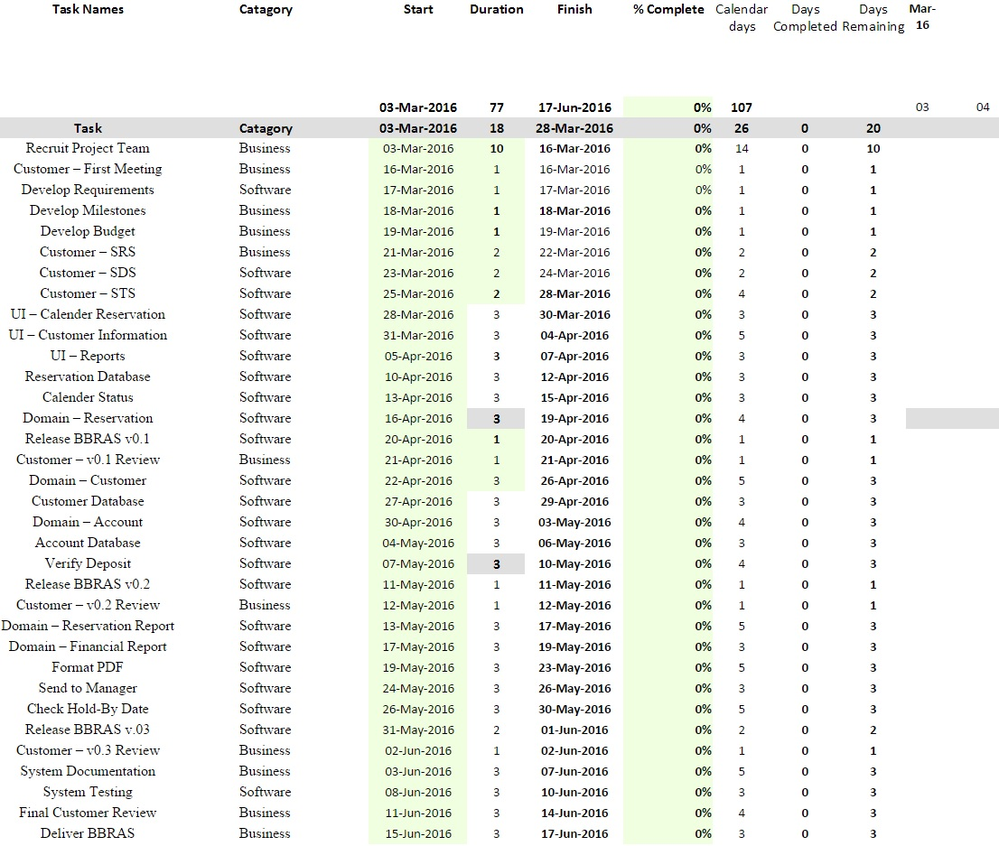

**5.1.3 Resource Allocation**

## **5.2 Risk Management Plan**

# **6. Technical Process Plans**

This section outlines the Project Team's processes and methods to plan, analyze, construct and test the source code based on the requirements.

## **6.1 Process Model**

The project will utilize the “water fall” linear method of development. This method will allow for starting development on project aspects with or without the management.

**6.2 Methods, Tools, and Techniques**

The Project Team will follow industry standards, listed in the following:

* Language: Java and Java APIs
* Database Implementation: Microsoft Access
* Source Control: Git
* Documentation: Microsoft Word

All source code will be tested, then commited, then Git will run a post-commit test. Any failure of the unit and integration tests will result in a roll-back to the previous Git commit. Any failure to commit will also be followed with documentation describing the error, what corrective actions to take to fix the error and what preventative actions to take to avoid the error in the future. Each software build that meets a milestone will be presented to the manager by the Project Manager for review.